Visual Studio

Conteúdo

Introduction 2
VS – Installation and Configuration 2
Download 2
Install 2
VS Command Line 5
VS Integrated Terminal 5
Customizing Environment Variables 6
VS - Solution 7
Creating an empty solution 7
Creating a Git Repository 8
Editing the Git config files inside VS 9
Atualização do Git 10
Push to Git automatically on Commit 11

Introduction
Microsoft Visual C++ (MSVC) refers to the C++, C, and assembly language development tools and libraries available as part of Visual Studio on Windows. These tools and libraries let you create Universal Windows Platform (UWP) apps, native Windows desktop and server applications, cross-platform libraries and apps that run on Windows, Linux, Android, and iOS, as well as managed apps and libraries that use the .NET Framework. You can use MSVC to write anything from simple console apps to the most sophisticated and complex apps for Windows desktop, from device drivers and operating system components to cross-platform games for mobile devices, and from the smallest IoT devices to multi-server high performance computing in the Azure cloud.

VS – Installation and Configuration

Download
Visual Studio should be downloaded from the following address:
https://visualstudio.microsoft.com/
On the Visual Studio page, select the right fields to download the Visual Studio accordingly with the environment you plan to develop as illustrated bellow:
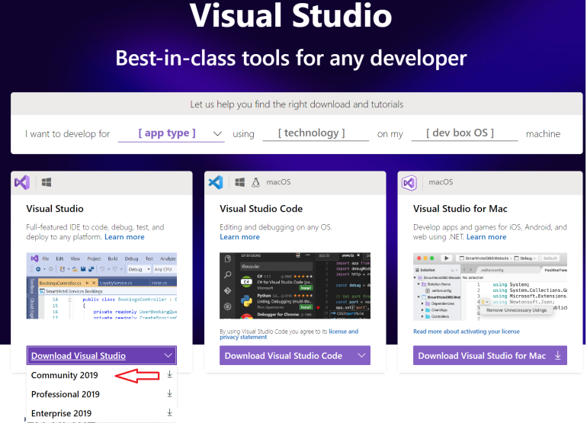

Install
Execute the Visual Studio just downloaded:
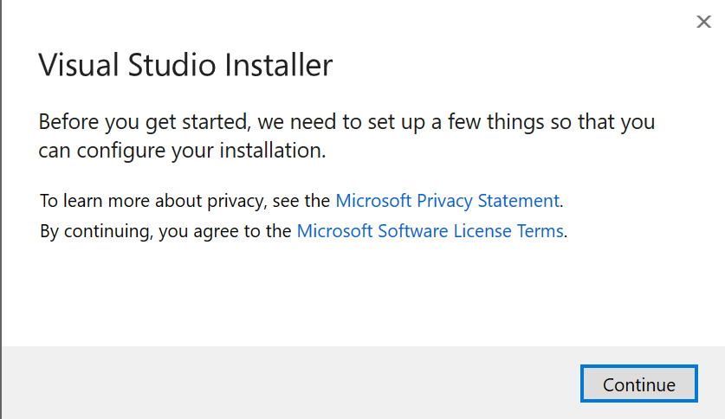

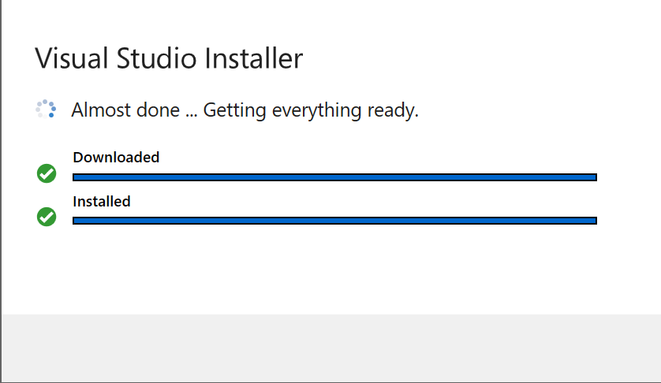
On the next screen you should select the workload to be installed. Note that the “Desktop development with C++” option will install the optional packages on the right panel including the CMake.
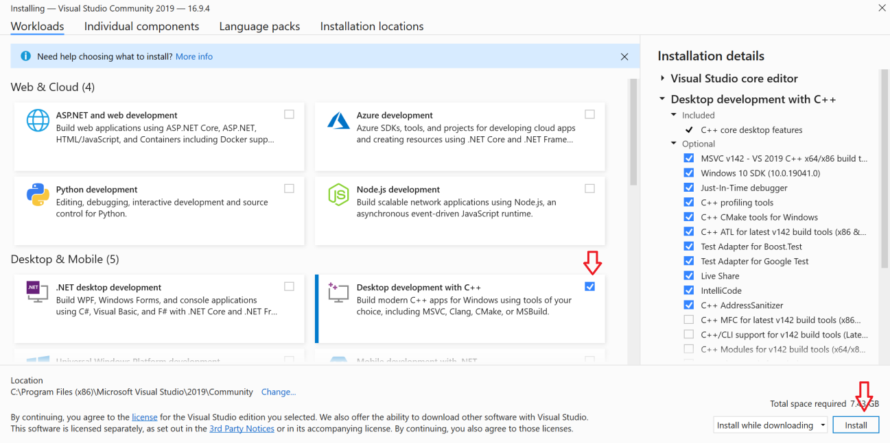
Include all desired language packs.
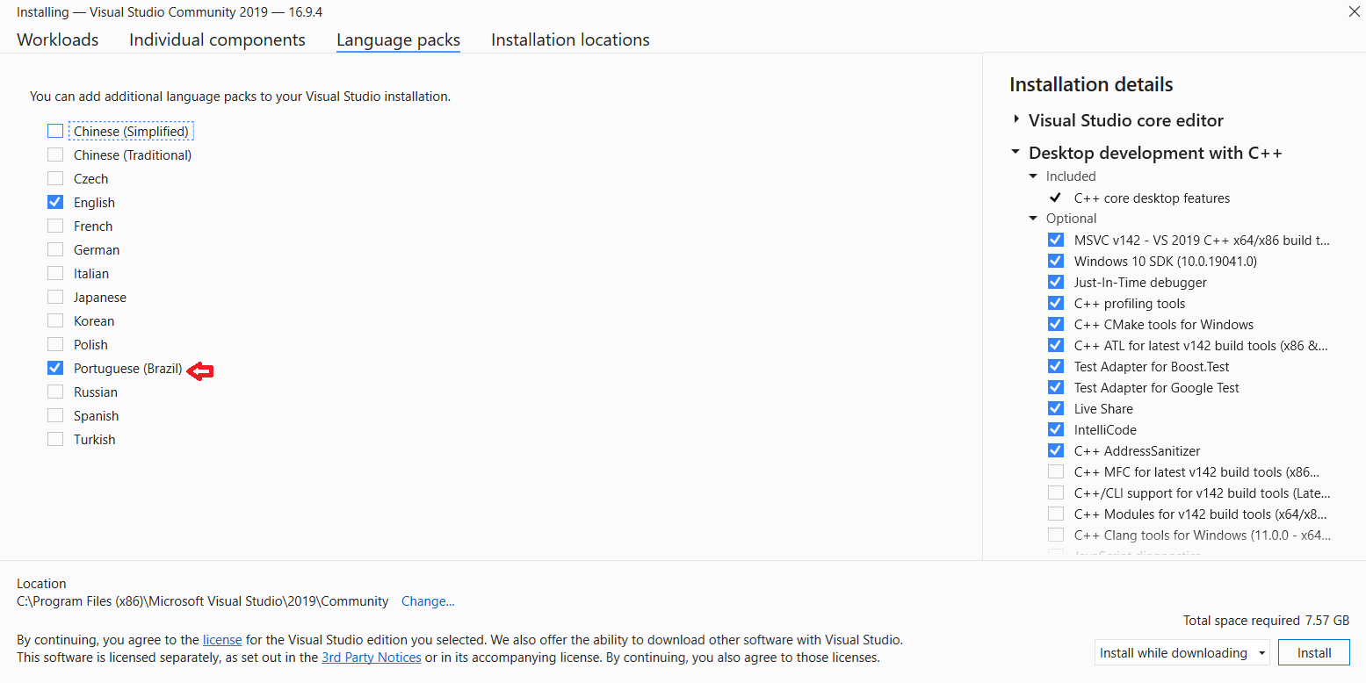

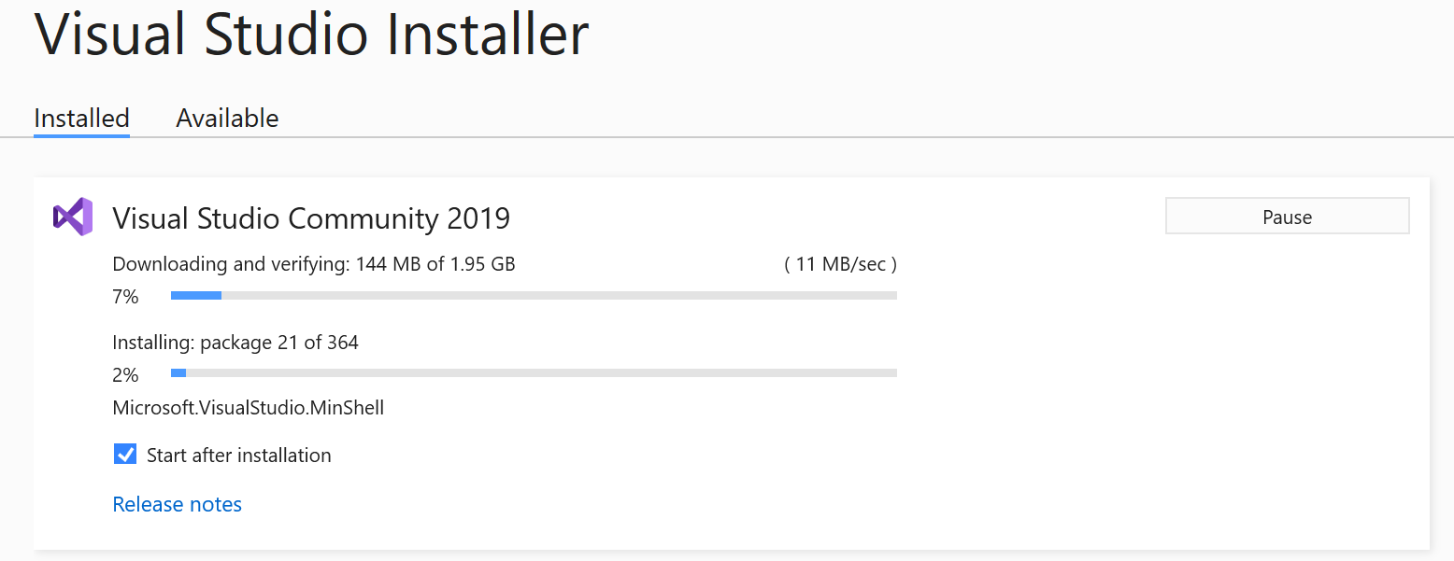

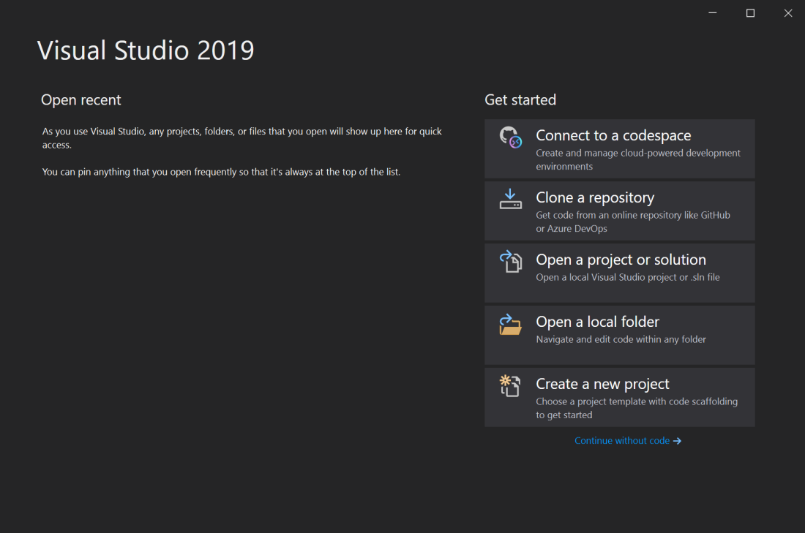

VS Command Line
On VS, the installed Tools will be accessible only inside the VS Command Line window by default. These tools are not natively available using windows CMD/Power Shell.
This is because when activating the VS Command Line, VS adjust all necessary environment variables to access all the tools installed.
To verify how this environment is prepared, check on VS: Tools -> Option -> Terminal
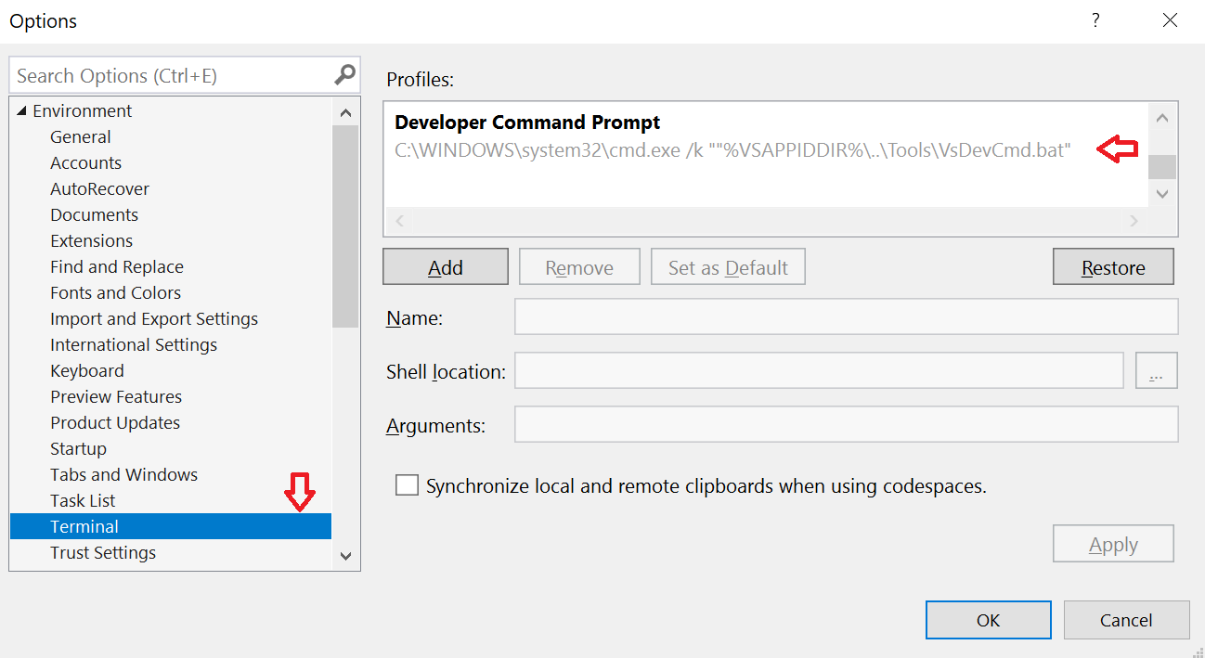
On the VS Command Line window we may check the defined environment variable as illustrated bellow:
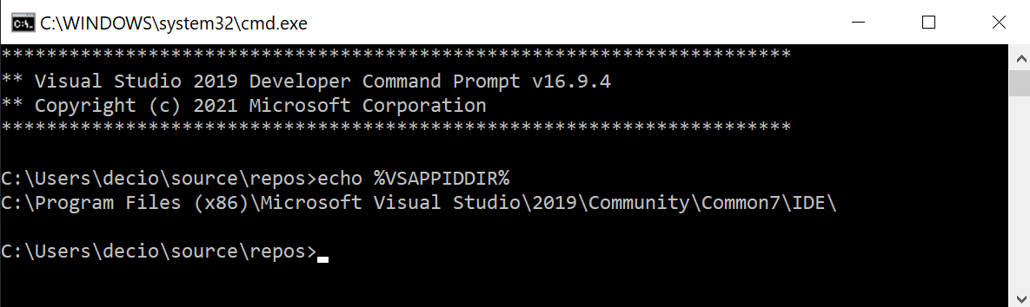

VS Integrated Terminal
Starting in Visual Studio 2019 version 16.5, Visual Studio includes an integrated terminal that can host either of these shells (Developer Command Prompt and Developer PowerShell). You can also open multiple tabs of each shell as illustrated bellow.
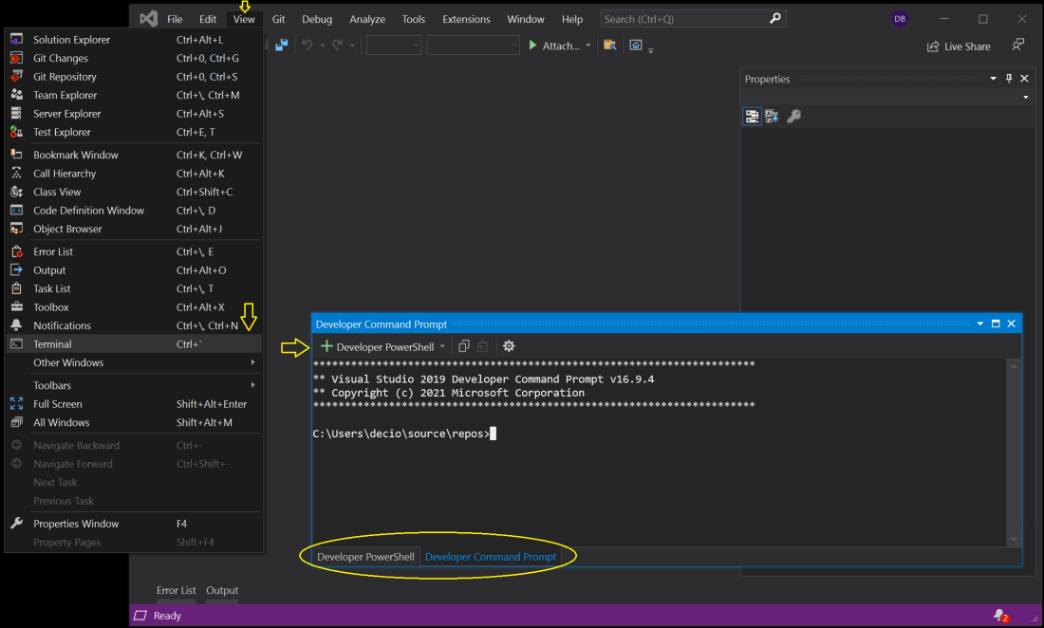

Customizing Environment Variables
There are now two ways to specify environment variables for CMake and C++ Open Folder. The first is to set up the overall build environment. This is done in CMakeSettings.json for CMake and CppProperties.json for C++ Open Folder.
Environment variables can be global for the project or specific to an individual configuration (selected with the configuration dropdown menu).
These environment variables will be passed to everything, including CMake builds, custom tasks, and debug targets.
Environment variables can also be used in any value in Visual Studio’s configuration JSON files using the syntax:
"${env.VARIABLE_NAME}"

VS - Solution
A solution is simply a container used by Visual Studio to organize one or more related projects.
When you open a solution in Visual Studio, it automatically loads all the projects that the solution contains.

Creating an empty solution
Use the following procedure to create a new empty solution:
- On the File menu, select New and then click Project.
- In the Project types pane, select Other Project Types and then select Visual Studio Solutions.
- In the Templates pane, select Blank Solution.
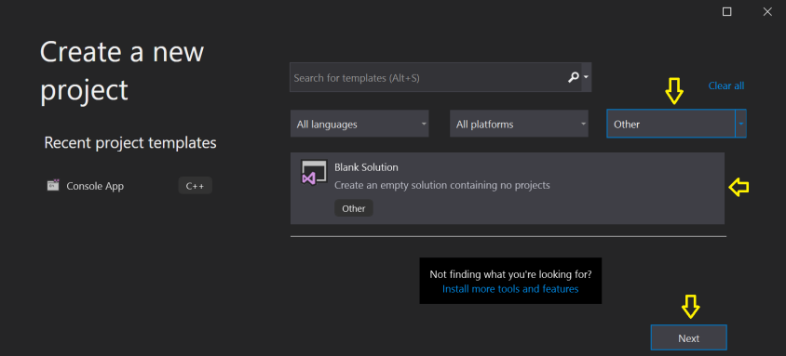
- Enter a name for the project.
- To change the location of the solution directory, choose Browse and specify a new location.
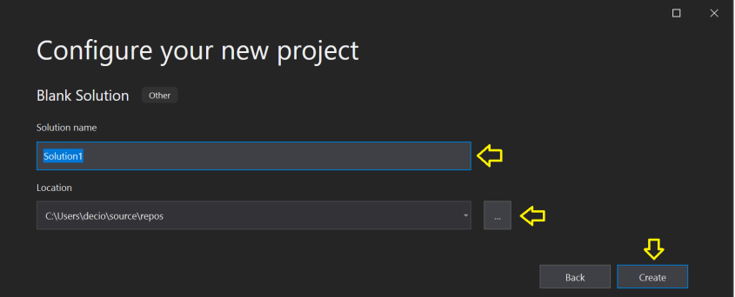
- Select Create to create the empty solution.
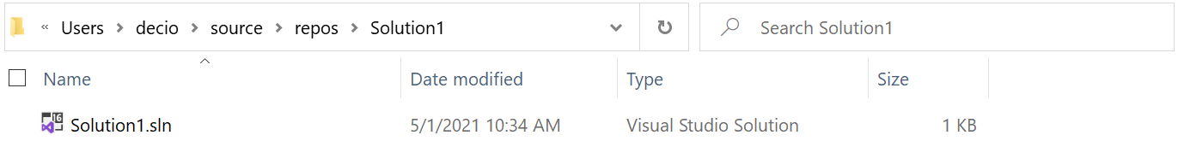
After the Solution Creation only one file will be created inside the solution sub-dir with the name specified before.
After creating an empty solution, you can add new or existing projects and items to the empty solution by using the Add New Item or Add Existing Item command from the Project menu.

Creating a Git Repository
After the Solution Creation, we may create a Git repository inside VS using the following procedure:
- On the Git menu, select Create a Git Repository…
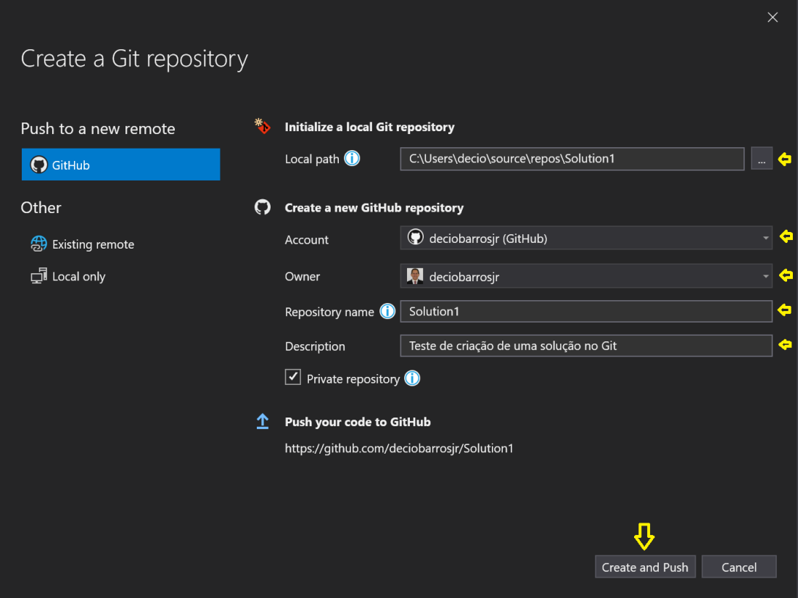
- On the form above, fill with the requested information and hit Create and Push.
After the successful creating of the Git repository, the following files will be created on the GitHub: .gitattributes and .gitignore
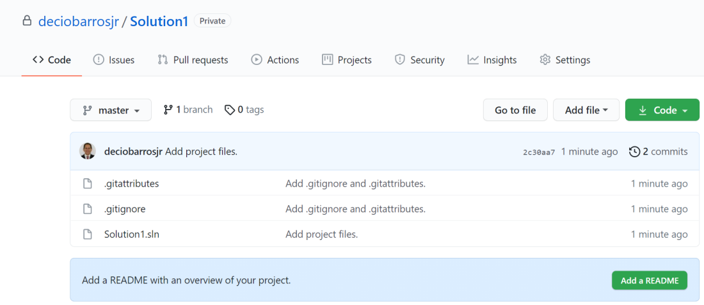
The same files will be created inside the solution sub-dir: .gitattributes and .gitignore
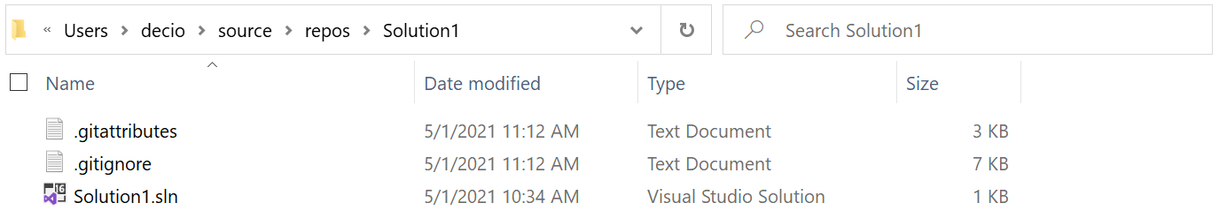

.gitattributes: This file allows you to specify the files and paths attributes that should be used by git when performing git actions, such as git commit, etc. In other words git automatically saves the file according to the attributes specified, every time a file is created or saved.
This file may be changes inside VS.
The complete documentation may be found on: https://www.git-scm.com/docs/gitattributes

.gitignore: tells git which files (or patterns) it should ignore. It's usually used to avoid committing transient files from your working directory that aren't useful to other collaborators, such as compilation products, temporary files IDEs create, etc.
This file may be changes inside VS.
The complete documentation may be found on: https://git-scm.com/docs/gitignore

Editing the Git config files inside VS
To edit the git files (.gitattributes .gitignore) inside VS we need to exchange the view to the Folder View using the View Switch Icon on the top of the solution explorer as illustrated bellow:
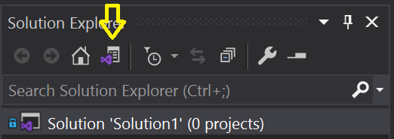
Next all available views will be shown on the Solution Explorer. Double click on the Folder View to access this view on the solution explorer.
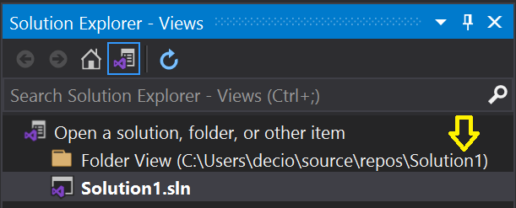
On the Folder View we may change the .git files as illustrated bellow:
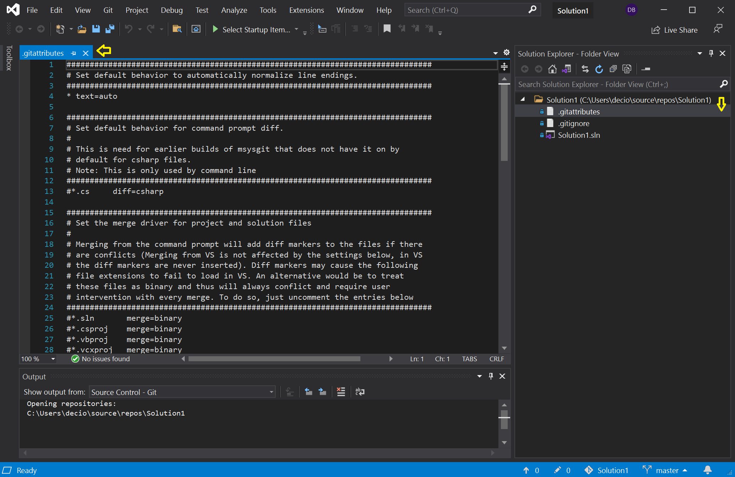

Creating a new project inside the solution

Apendice A – useful extensions for Visual Code

REST CLIENT: Here is a Visual Studio Code extension that many of you (me included) will find extremely useful. Rest Client allows you to perform HTTP requests and view the responses directly inside Visual Studio Code.
VSCODE-JSON: If you work with JSON at all, and I am sure that at some point in your career, you will, then this Visual Studio Code extension will come in quite handy. It’s a small and simple extension, but one that allows you to beautify, uglify, escape, and unescape JSON
https://marketplace.visualstudio.com/items?itemName=eamodio.gitlens
https://marketplace.visualstudio.com/items?itemName=mhutchie.git-graph

